<https://github.com/mijafro/Charcrete-LCA>

Script “Start here” Notebook:

# 🎉 Charcrete LCA Group Project 👩‍💻

[Click here to get the Autumn School teaching material](https://autumn.brightway.dev/hub/user-redirect/git-pull?repo=https://github.com/mijafro/Charcrete-LCA&urlpath=lab%2Ftree%2FCharcrete-LCA%2F)

1. Download and install Git: <https://git-scm.com/download/win>
2. Launch “Git Bash” and configure with:

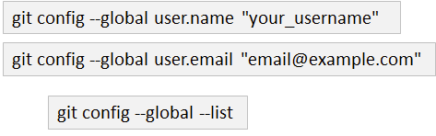

1. Create a folder :



1. Git init: